# Projet Learn@Home

Notes - Réunion lancement du projet

Presentation of the project

Learn@Home is an association that brings together children with learning difficulties and volunteers, online. Their objective is to allow any student, wherever he or she may be, to access distance learning support.

Each student registered on the site has a volunteer tutor assigned to them. The aim of the volunteer is to support the student in his/her learning through short appointments scheduled each week. During these appointments, the volunteer helps the student with homework and organisation.

To facilitate interaction and communication, Learn@Home would like to create a new website, which should consist of the following pages

1. A login page

2. A dashboard page

3. A chat interface page

4. A calendar page

5. A task management page

Details page by page

1. The login page

The login page should allow a student or volunteer to log in. All other pages can only be accessed once logged in to an account. This page should include :

- A system for retrieving a forgotten password

- A link to an account creation page

The following is a sketch of the client's expectations in terms of the interface:

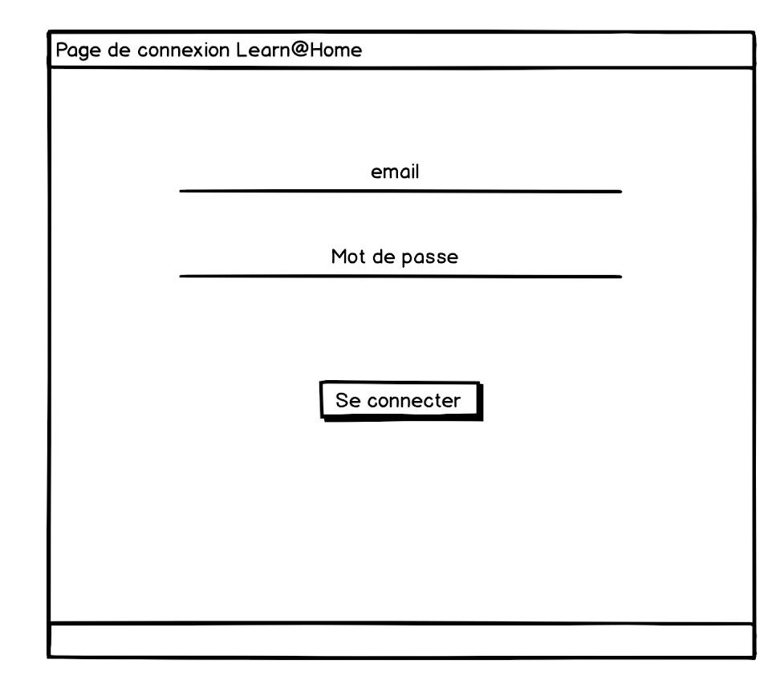

1. The dashboard

This page will serve as the main page and should therefore contain a summary of all recent and important information from the other pages: chat, calendar, task management.

The page will display :

- A summary of tasks (to-do list) from the task management page (5.)

- the list of upcoming events, from the calendar page (4.)

- An unread message counter.

2. The chat interface

The Learn@Home chat interface is a classic chat page, integrating an instantaneous discussion system between students and volunteers. It should also allow access to the history of conversations, and to add or delete a contact.

Below is a sketch of Learn@Home's expectations for this page. Other elements should be added:

- The sender's profile picture, next to each message

- An indicator to show whether a message has been read or not.

- The time stamp of the messages

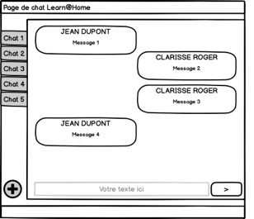

1. The calendar page

The Learn@Home calendar page corresponds to a classic calendar page, on which the user's various events and appointments are displayed.

2. The task management page

The interface of this page must allow the creation of tasks for oneself or for another user.

● The student can only create tasks for himself.

● The volunteer can create tasks for the students he/she follows.